**Bank Loan Report Query Document**

Bank Loan Report | Summary

KPI’s

Total Loan Application

select COUNT(id) as Total_loan_Application from bank_loan_data;

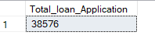

PMTD Loan Application

select COUNT(id) as PMTD_Total_loan_Application

from bank_loan_data

where MONTH(issue_date)=11 AND YEAR(issue_date) = 2021



Total Funded Amount

select sum(loan_amount) as MTD_Total_Funded_Amount from bank_loan_data

where MONTH(issue_date) = 12 AND YEAR(issue_date) = 2021



PMTD Total Funded Amount

select sum(loan_amount) as PMTD_Total_Funded_Amount from bank_loan_data

where MONTH(issue_date) = 11 AND YEAR(issue_date) = 2021



MTD Total Amount Received

select SUM(total_payment) as MTD_Total_Amount_Received from bank_loan_data

where MONTH(issue_date) = 12 AND YEAR(issue_date) = 2021



PMTD Total Amount Received

select SUM(total_payment) as PMTD_Total_Amount_Received from bank_loan_data

where MONTH(issue_date) = 11 AND YEAR(issue_date) = 2021

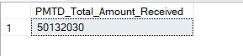

MTD AVG Intrest Rate

select ROUND(AVG(int_rate), 4) * 100 as MTD_Avg_interest_rate from bank_loan_data

where MONTH(issue_date) = 12 AND YEAR(issue_date) = 2021

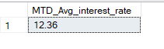

PMTD AVG Intrest Rate

select ROUND(AVG(int_rate), 4) * 100 as PMTD_Avg_interest_rate from bank_loan_data

where MONTH(issue_date) = 11 AND YEAR(issue_date) = 2021

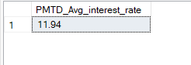

MTD AVG Intrest DTI

select ROUND(AVG(dti),4) * 100 as MTD_AVG_Dti from bank_loan_data

where MONTH(issue_date)=12 AND YEAR(issue_date) = 2021

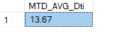

PMTD AVG DTI

select ROUND(AVG(dti),4) * 100 as PMTD_AVG_Dti from bank_loan_data

where MONTH(issue_date)=11 AND YEAR(issue_date) = 2021

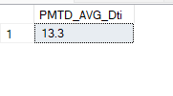

PROBLEM STATEMENT :

Good loan Percentage

select

(COUNT(CASE WHEN loan_status = 'Fully Paid' or Loan_status = 'Current' THEN id END)*100)

/

COUNT(id) AS Good_loan_Percentage

from bank_loan_data



Good loan Status

select count(id) as Good_loan_status from bank_loan_data

where loan_status = 'Fully Paid' or loan_status = 'Current'

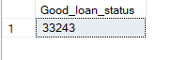

Good loan Amount

select sum(loan_amount) as Good_loan_Amount from bank_loan_data

where loan_status = 'Fully Paid' or loan_status = 'Current'

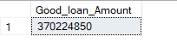

Good loan Amount Received

select sum(total_payment) as good_loan_amount_received from bank_loan_data

where loan_status = 'Fully Paid' or loan_status = 'Current'

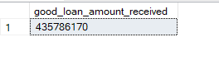

Bad loan Percentage

select

(count(case when loan_status = 'Charged Off' Then id end)*100.0) /

COUNT(id) as Bad_loan_percentage

From bank_loan_data

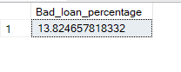

Bad loan Application

select COUNT(id) as bad_loan_application from bank_loan_data

where loan_status = 'Charged Off'

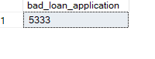

Bad loan Funded

select sum(loan_amount) as bad_loan_funded from bank_loan_data

where loan_status = 'Charged Off'

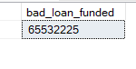

Bad loan Received

select sum(total_payment) as bad_loan_received from bank_loan_data

where loan_status = 'Charged Off'

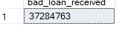

Bad loan Funded

select sum(loan_amount) as bad_loan_funded from bank_loan_data

where loan_status = 'Charged Off'



Loan status - Total Application

select

loan_status,

COUNT(id) as total_applications,

sum(total_payment) as Total_Amount_Received,

sum(loan_amount) as total_funded_amount,

AVG(int_rate * 100) as intrest_rate,

AVG(dti*100) as DTI

from

bank_loan_data

group by

Loan_status

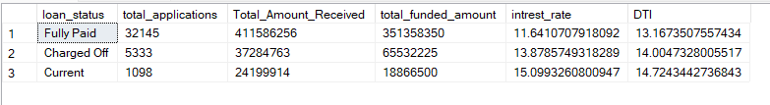

Loan status - Total Received

select

loan_status,

sum(total_payment) AS MTD_Total_Received,

sum(loan_amount) AS MTD_Total_Funded_Amount

FROM bank_loan_data

WHERE Month(issue_date) = 12

GROUP BY loan_status

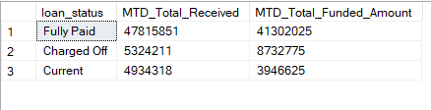

Month wise - Total Loan Application, Total funded Amount, Total received amount

select

DATENAME(MONTH, issue_date) as Month_Name,

COUNT(id) as Total_loan_pplication,

SUM(loan_amount) as Total_funded_amount,

SUM(total_payment) as Total_received_amount

from bank_loan_data

group by DATENAME(MONTH, issue_date)

order by DATENAME(MONTH, issue_date)

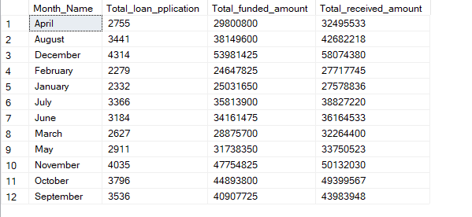

Address state - Total Loan Application, Total funded Amount, Total received amount

select

address_state,

COUNT(id) as Total_loan_application,

SUM(loan_amount) as Total_funded_amount,

SUM(total_payment) as Total_received_Amount

from bank_loan_data

group by address_state

order by address_state

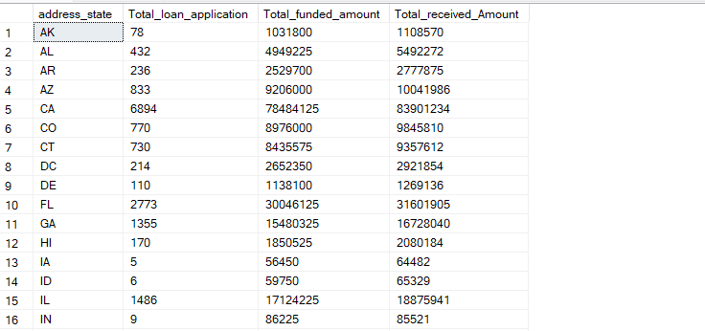

Term wise - Total Loan Application, Total funded Amount, Total received amount

select

term,

COUNT(id) as Total_loan_application,

SUM(loan_amount) as Total_funded_amount,

SUM(total_payment) as Total_received_Amount

from bank_loan_data

group by term

order by term

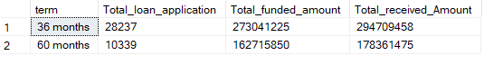

Employee Length - Total Loan Application, Total funded Amount, Total received amount

select

emp_length,

COUNT(id) as Total_loan_application,

SUM(loan_amount) as Total_funded_amount,

SUM(total_payment) as Total_received_Amount

from bank_loan_data

group by emp_length

order by COUNT(id) desc

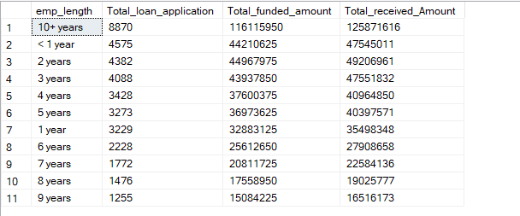

Loan Purpose - Total Loan Application, Total funded Amount, Total received amount

select

purpose,

COUNT(id) as Total_loan_application,

SUM(loan_amount) as Total_funded_amount,

SUM(total_payment) as Total_received_Amount

from bank_loan_data

group by purpose

order by purpose

